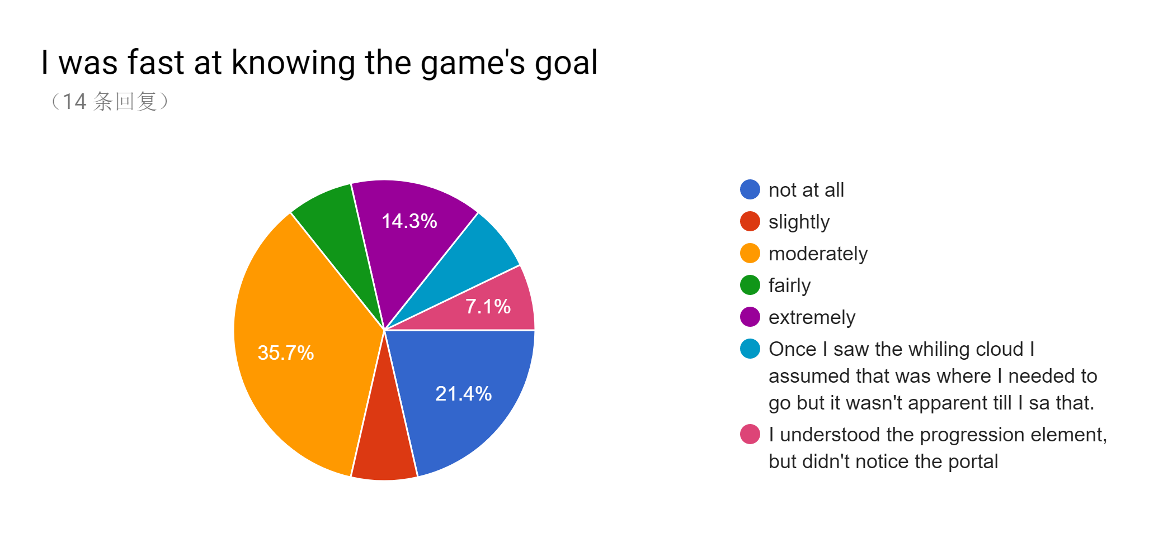

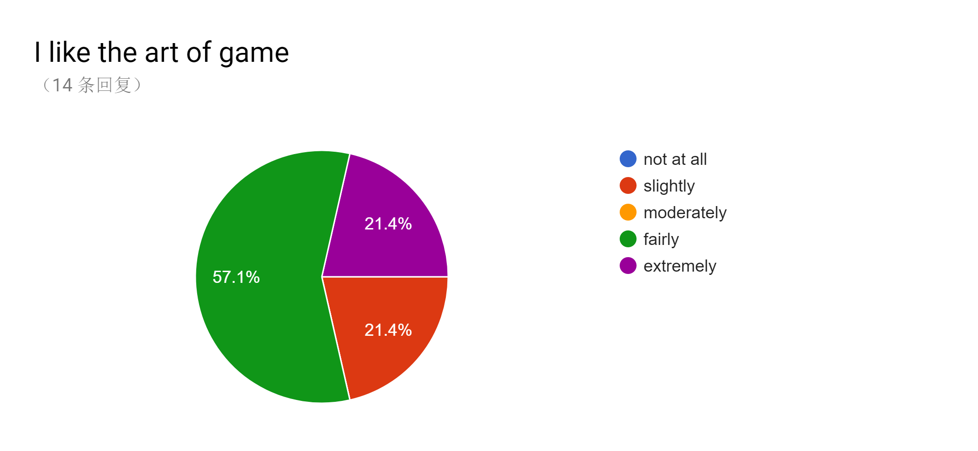

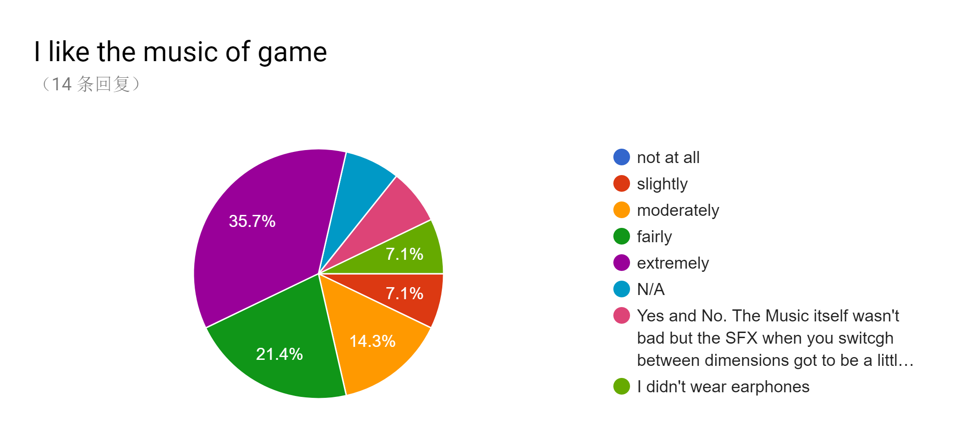

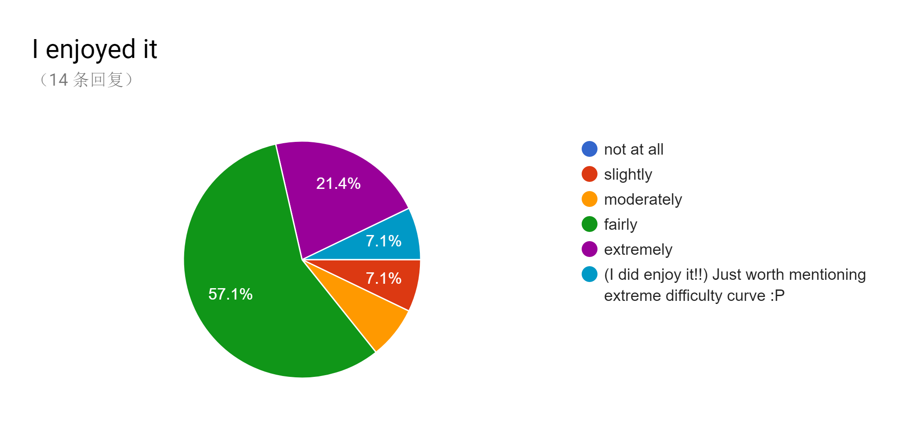

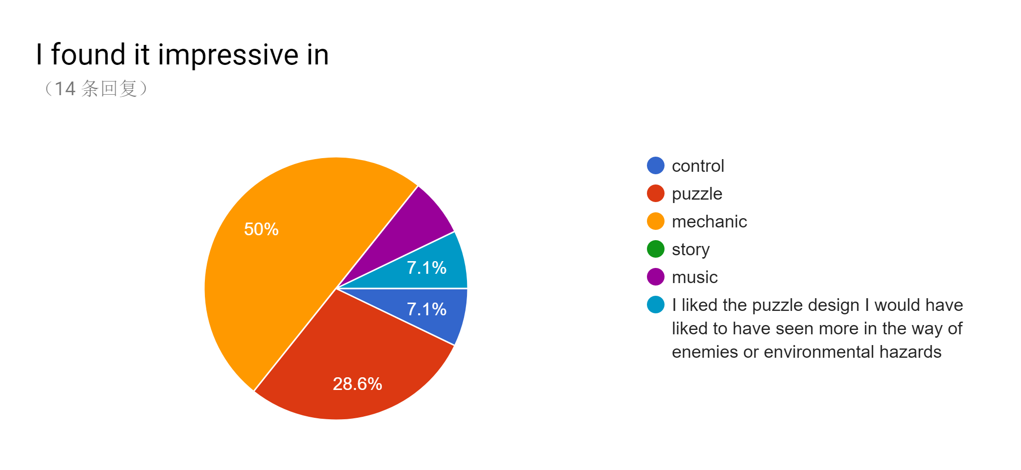

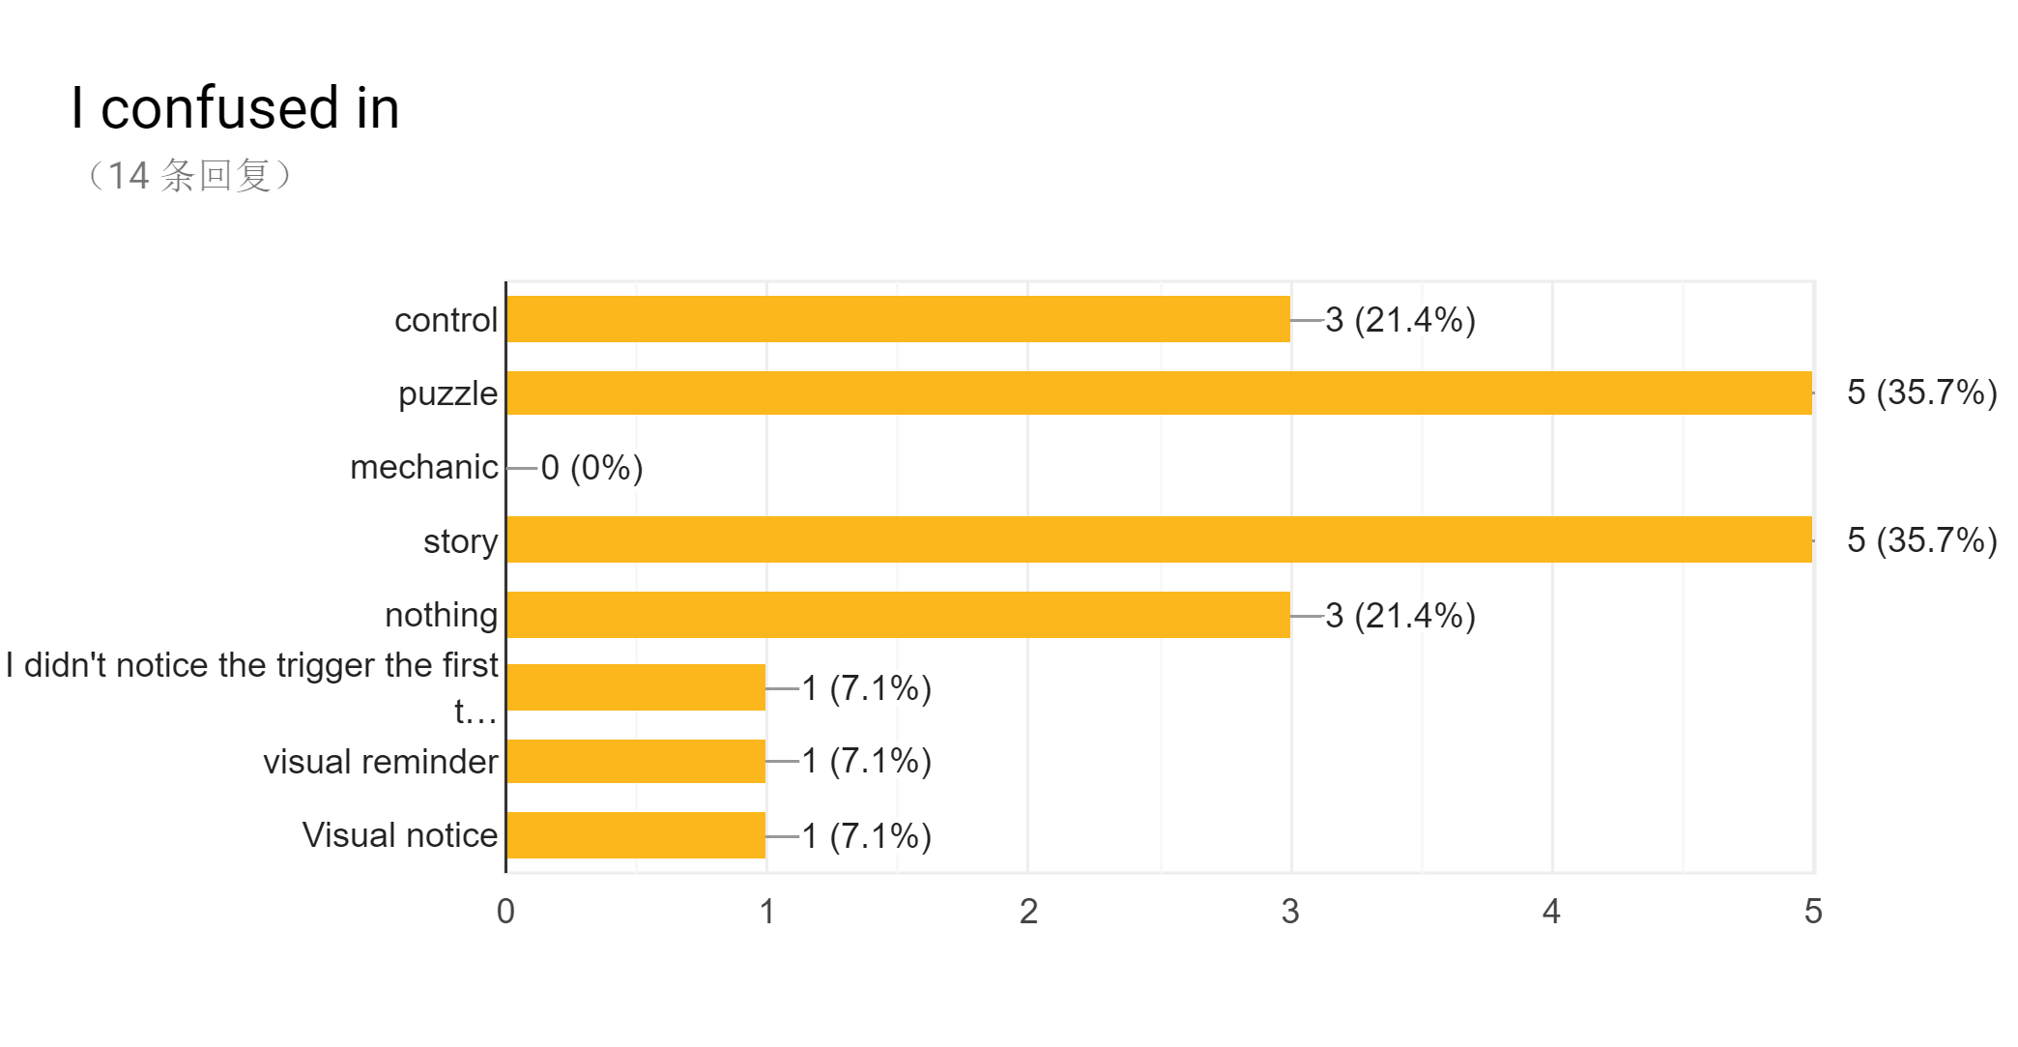

|  |
| --- |
| 1. If the yellow trigger links to the yellow platform and red trigger links to the red plat form, that would be easier to find the rout. 2. Some trigger looks the same, better to make every of them identified from others. 3. I don't understand why the most used mechanism (the trigger) appears much simpler than the wall. 4. The frequency change of background music when changing between platforms are impressive, but when I change fast between platforms, it makes the music wired. |
| I personal suggest chose one of the up arrow and space to control jump not both of them. The color of the whole world maybe can be more strong differentiation. The conversation can be shorter. |
| the status of ¬world-changing¬ block is not so obvious. When the block can't interactive anymore, it should be black or dull. The music and mechanics are good. If the world become more open and has more different solutions, the game will be excellent. The world-changeing mechanic can be multi-thread and including more optional routes of a platformer. For the turotial, it's better to teach player to beat a small level and to leave a apperent goal in players' first impression. The dialog is too long..... |
| The sequence with the boulder in the yellow room. The spaces are far to narrow. |
| The puzzle is actually interesting, but a little bit lack of clue. The level is linier, it's more like an advanture game not a puzzle game to me., and the gravity seems too high. |
| Possibly clearer distinction of which realm you would transport to in each platform |
| Give a better explanation how the puzzle works (I didn't get how the moving blocks work) |
| I found a dead loop (maybe a bug). And then when I tried to go into the dead loop again I found it could be the second way to victory. I think you fix this a little bit and make it to be the real second way. |

Summary:

1. At the start of game, goal is not that obvious.

we can move camera for few seconds to show the player the goal, with dialogue.

1. Too much text.
2. The goo at the start of game, is the place the most people dead, we can reduce the difficult of this place.
3. The logic of colour change in teleport platform, should be fixed. If some platform just move once and we don’t want player move back, we can locked it and make it colour like normal platform.
4. If we can give a simple tutorial at the start of game, to teach player how to use teleport platform?And we can add a hint when player stand on platform(Press”F”)
5. The rock trail is too difficult.
6. The lever should use the more obvious sprite.
7. After Friday we change the level design, we need to avoid the new level bug.